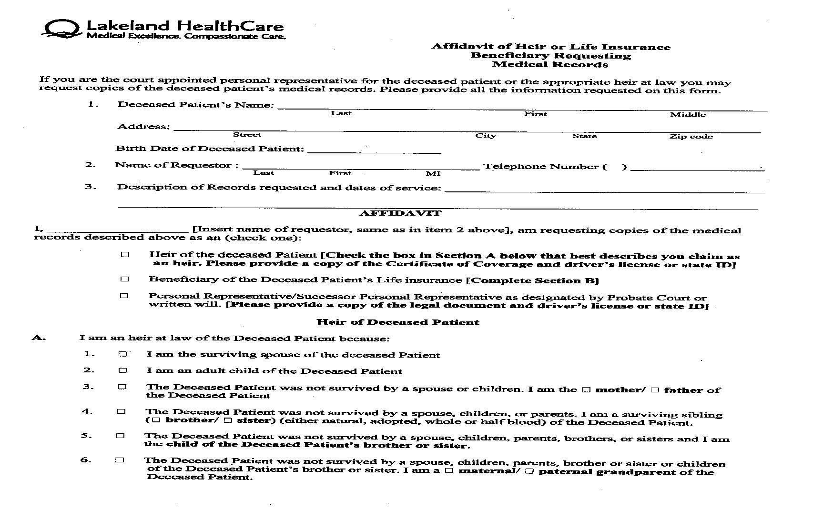

Order No. 01-23227 - 004
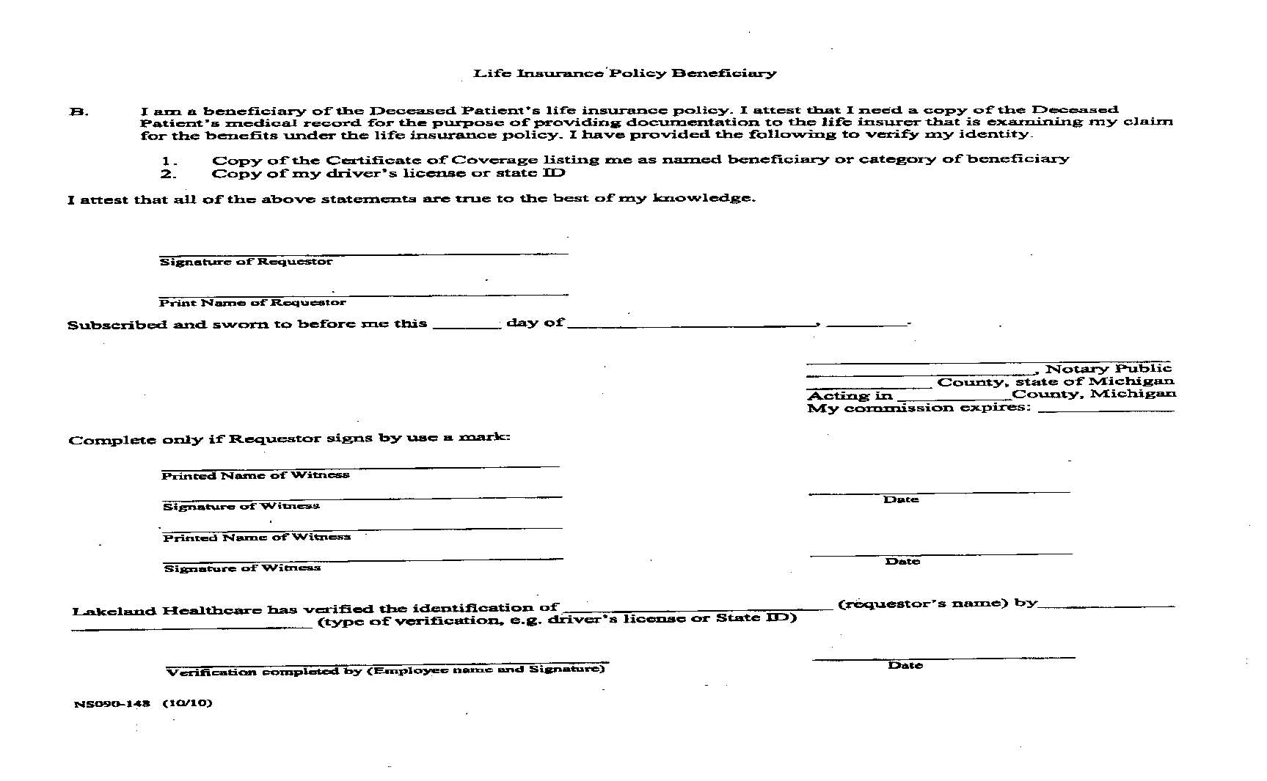
`
Order No. 01-23227 - 004

